Class 🡪 class 🡪 Extends  
interface 🡪 class 🡪 implements  
interface 🡪 Interface 🡪 extends

Exception Handling:  
Exceptions:   --> unexpected situations

 2 categoried  
    - Checked  ---> compile time  
    - Unchecked  ---> Runtime time..

   pre defined exception classes  
    FileNotFound  
    ArrayIndexoutofBounds exception  
    NullPointer Exception  
    Arthematic Exception ...  
  
  user defined Exceptions  
  
try catch blocks  
  try{

  }catch(Exception ex){

}catch(ArthematicException ex1{  
  
   }  
  finally{

sout(" ");  
  }

Task001:

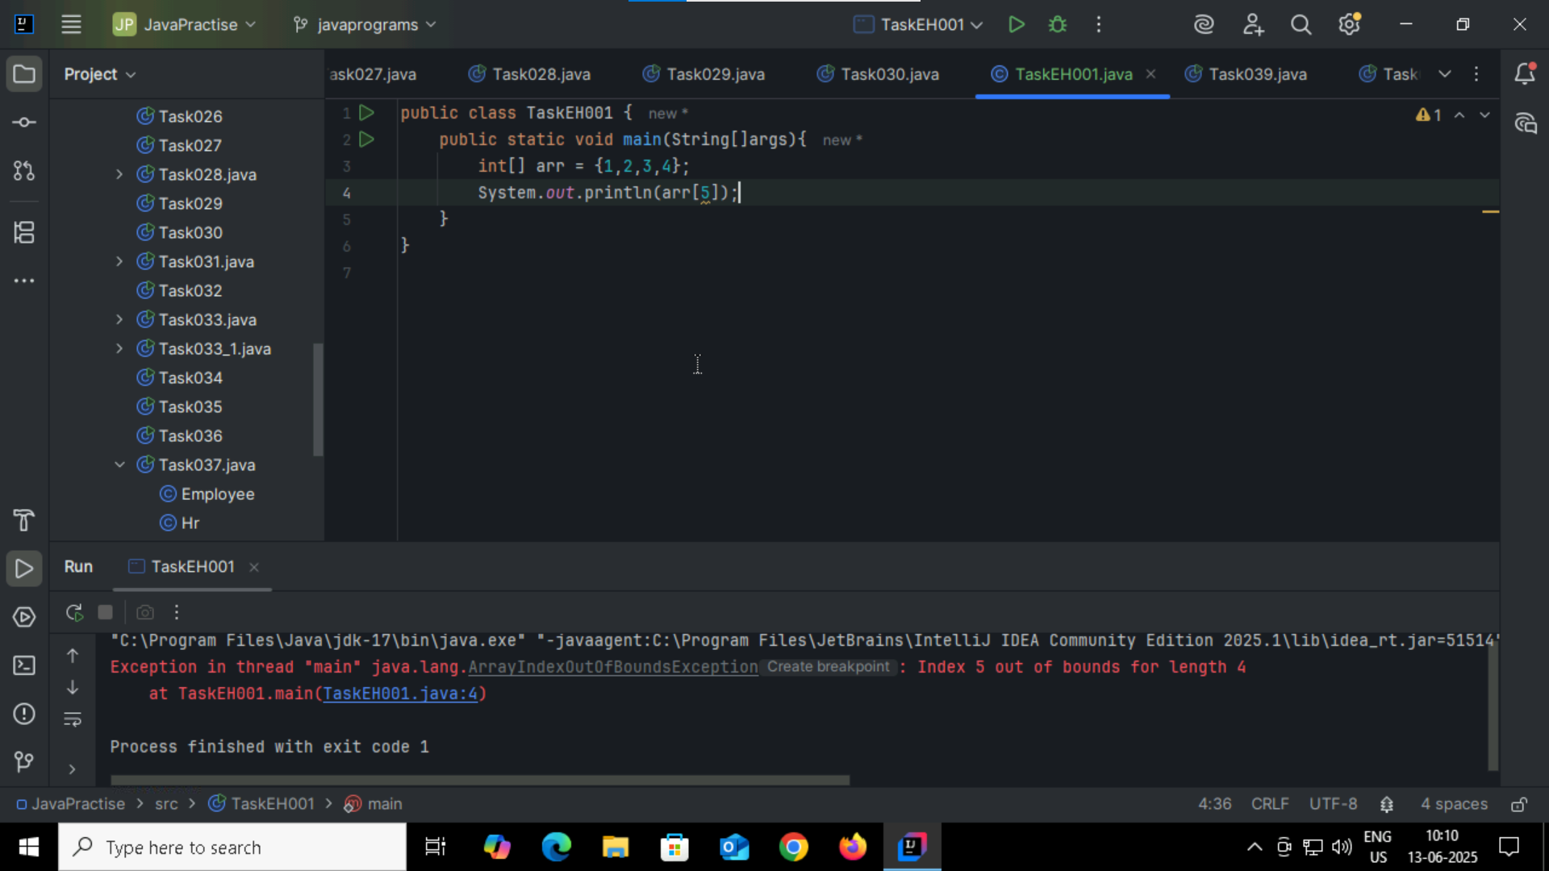

Task002: try , catch

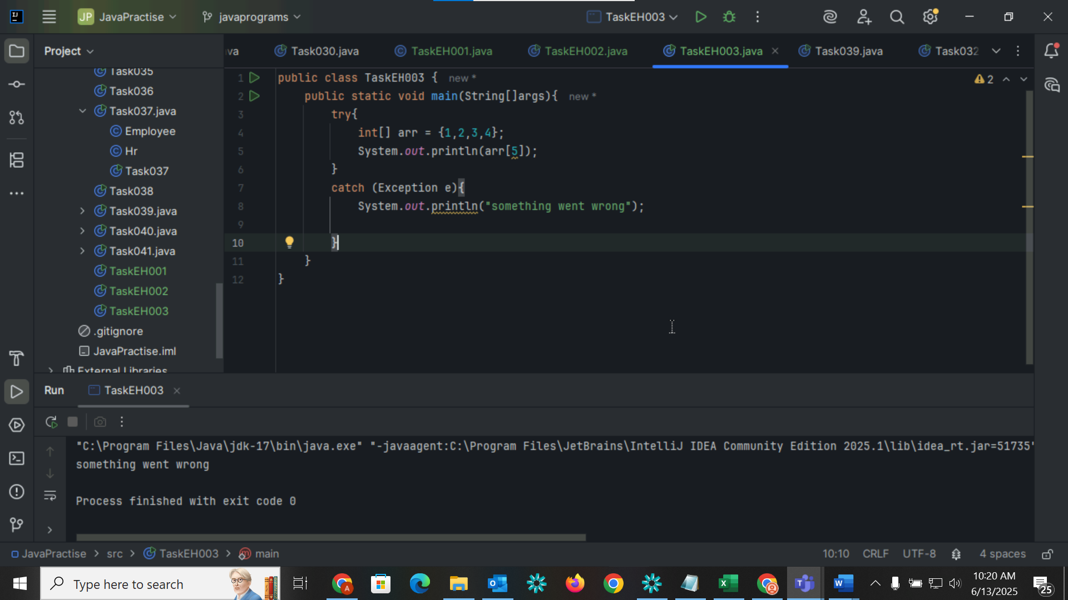

Task003: try , catch , finally

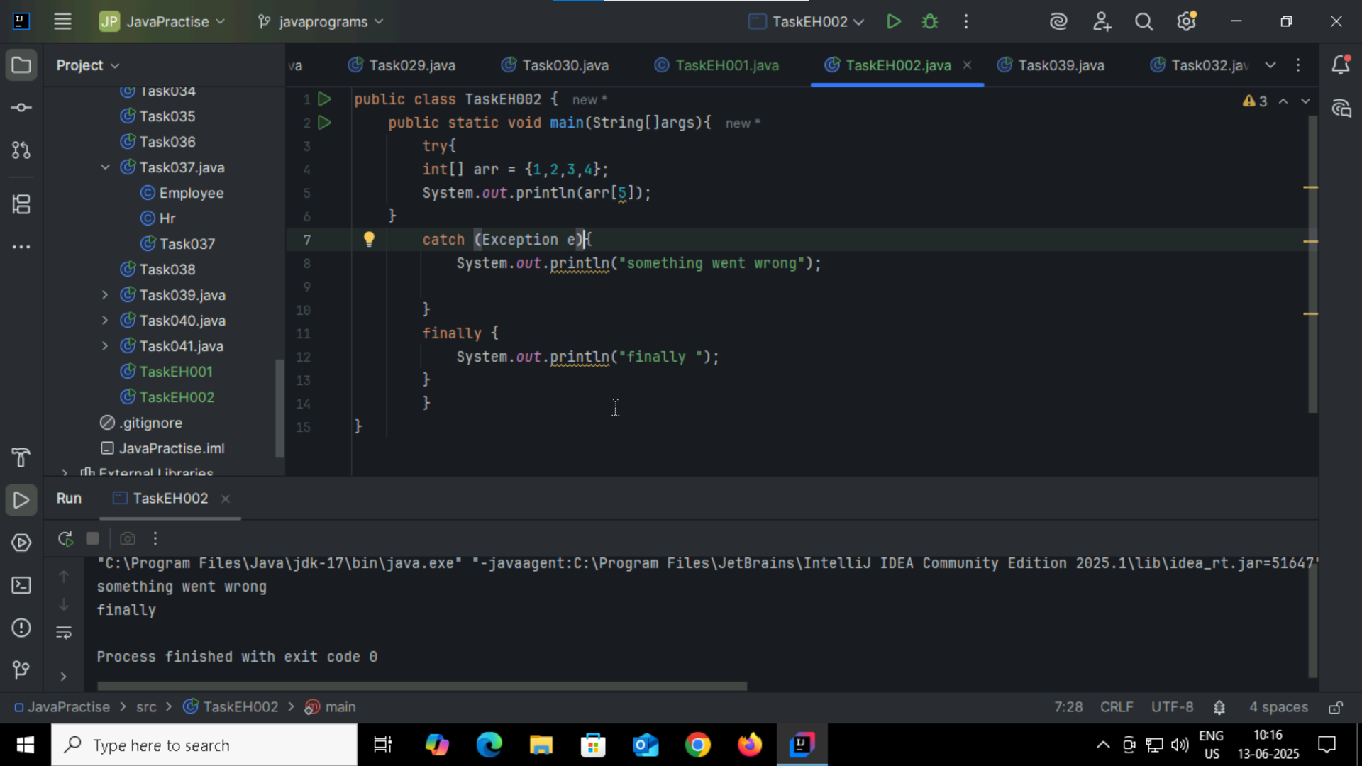

Task004:

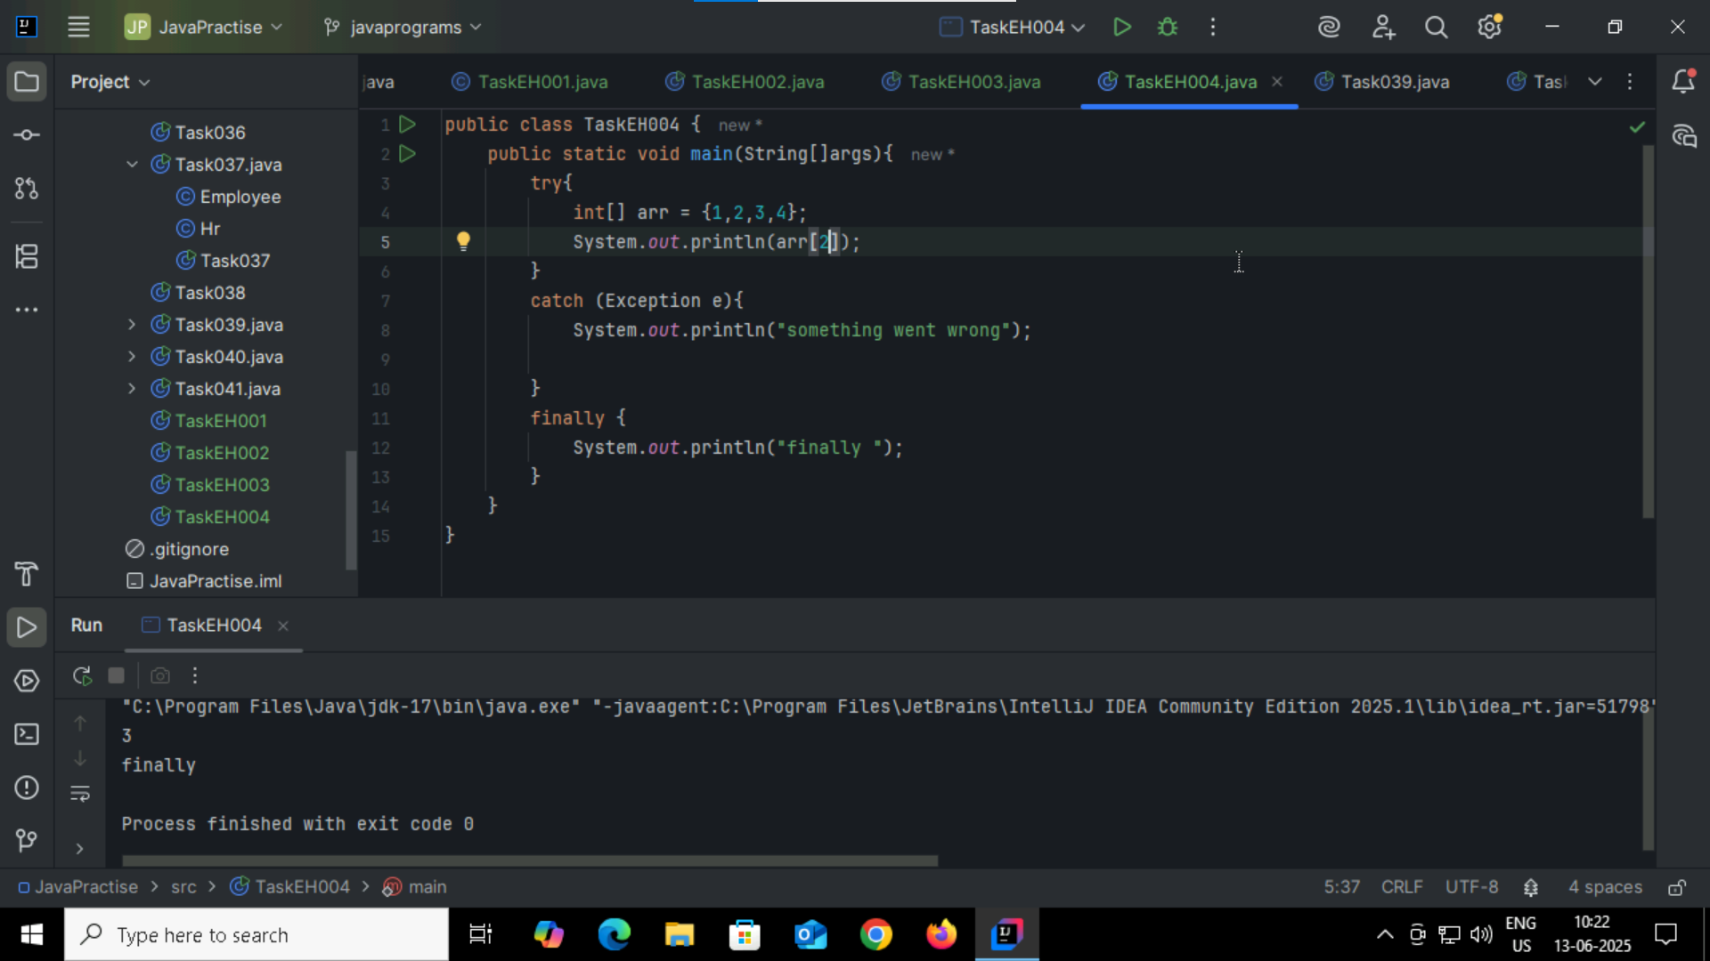

Task005:

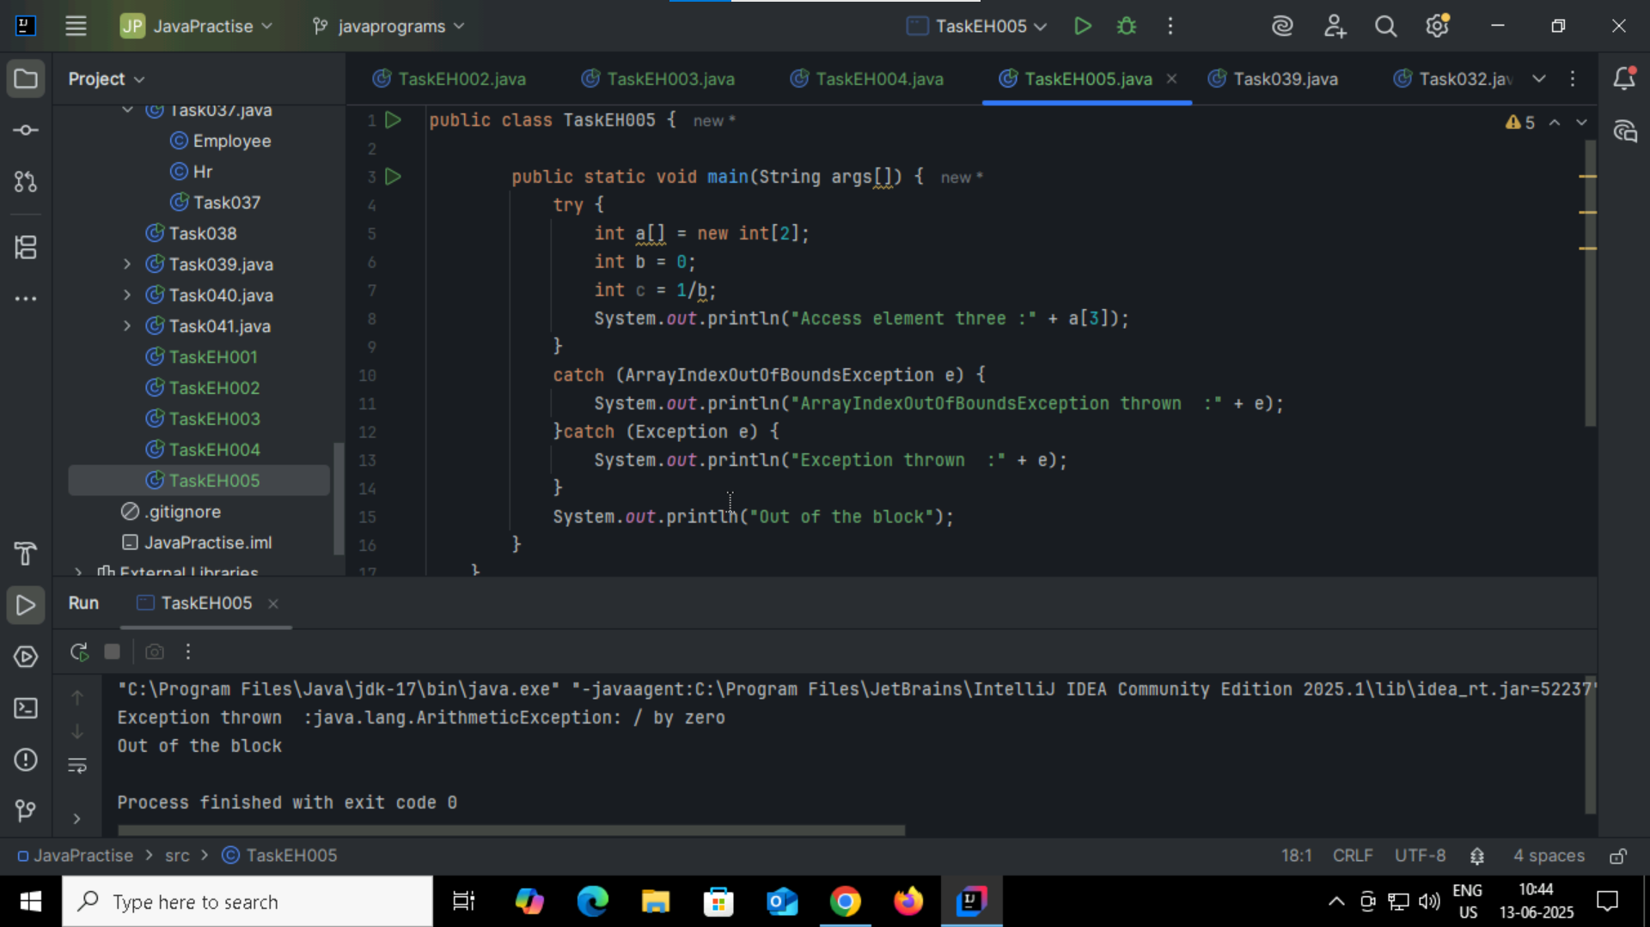

Task005_1 try changing 0 to 10:

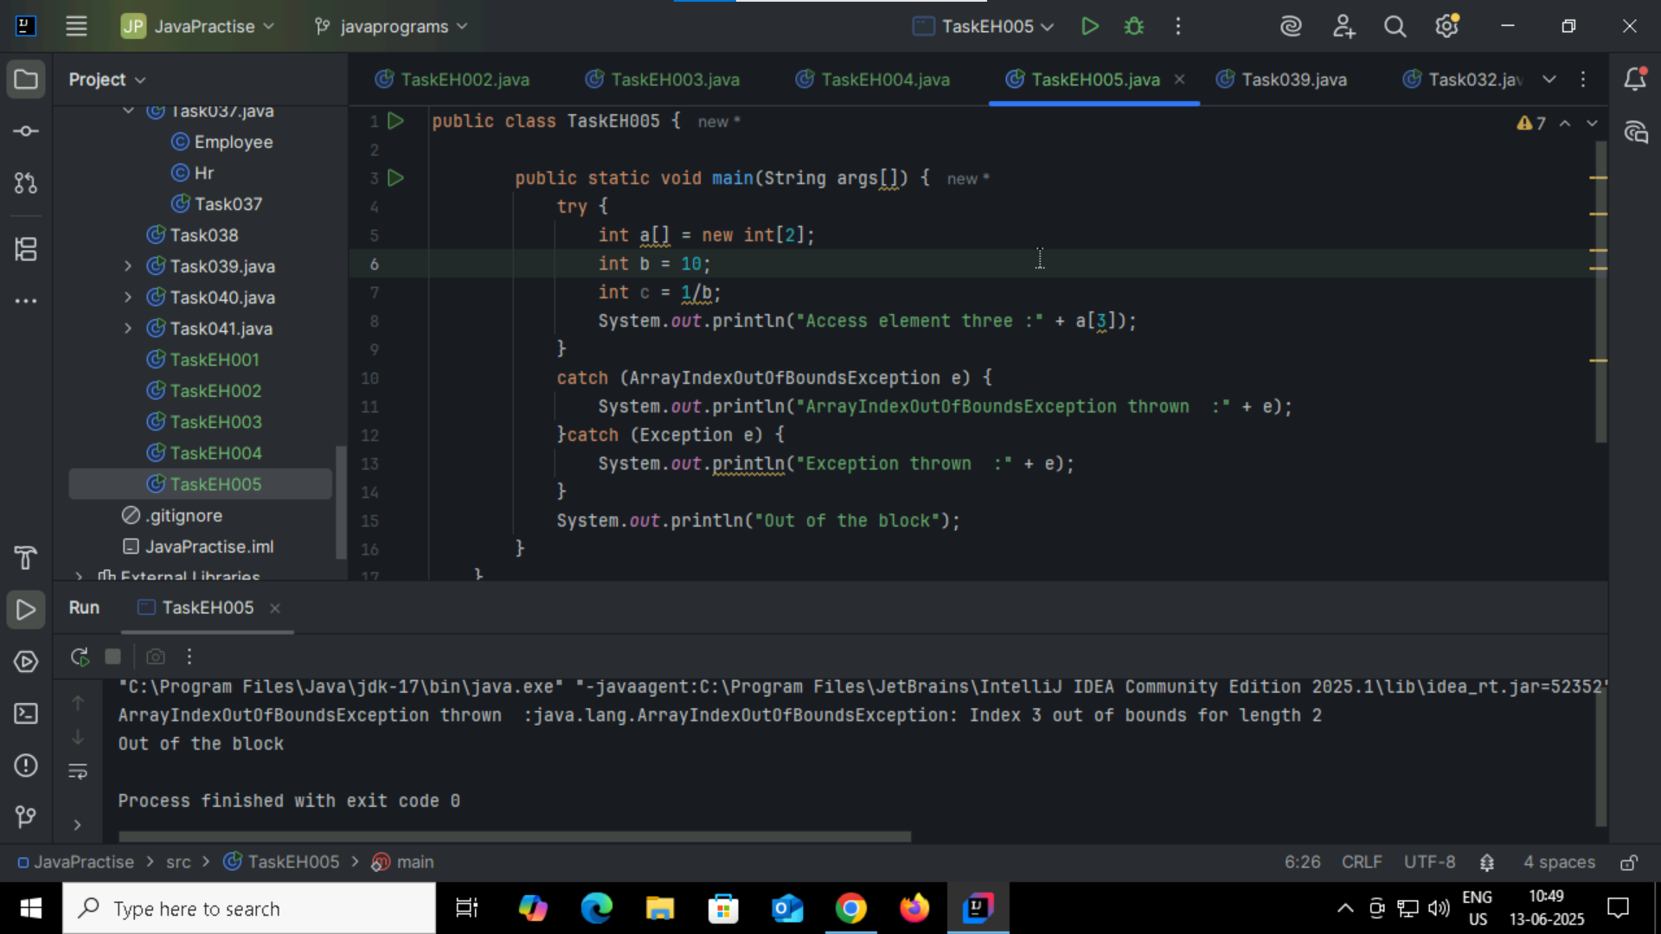

Task003_1  
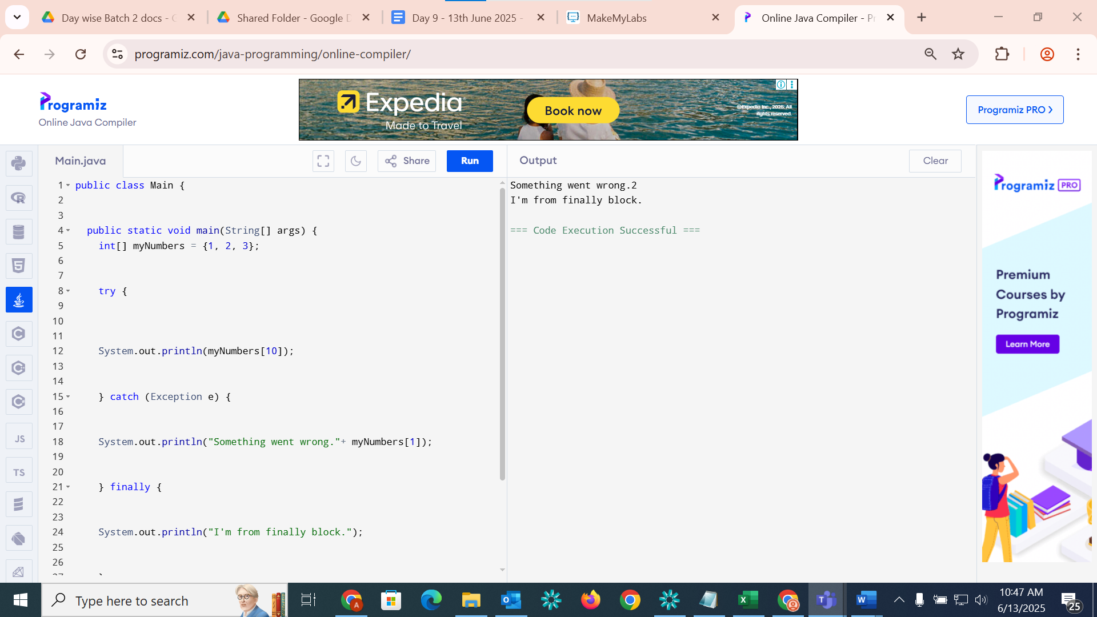Task006

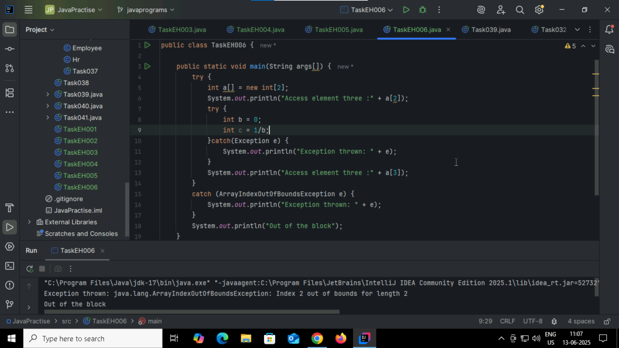

Task006_1: changing // try with a[0] or a[1]  ===> and check if control goes to inner try block..

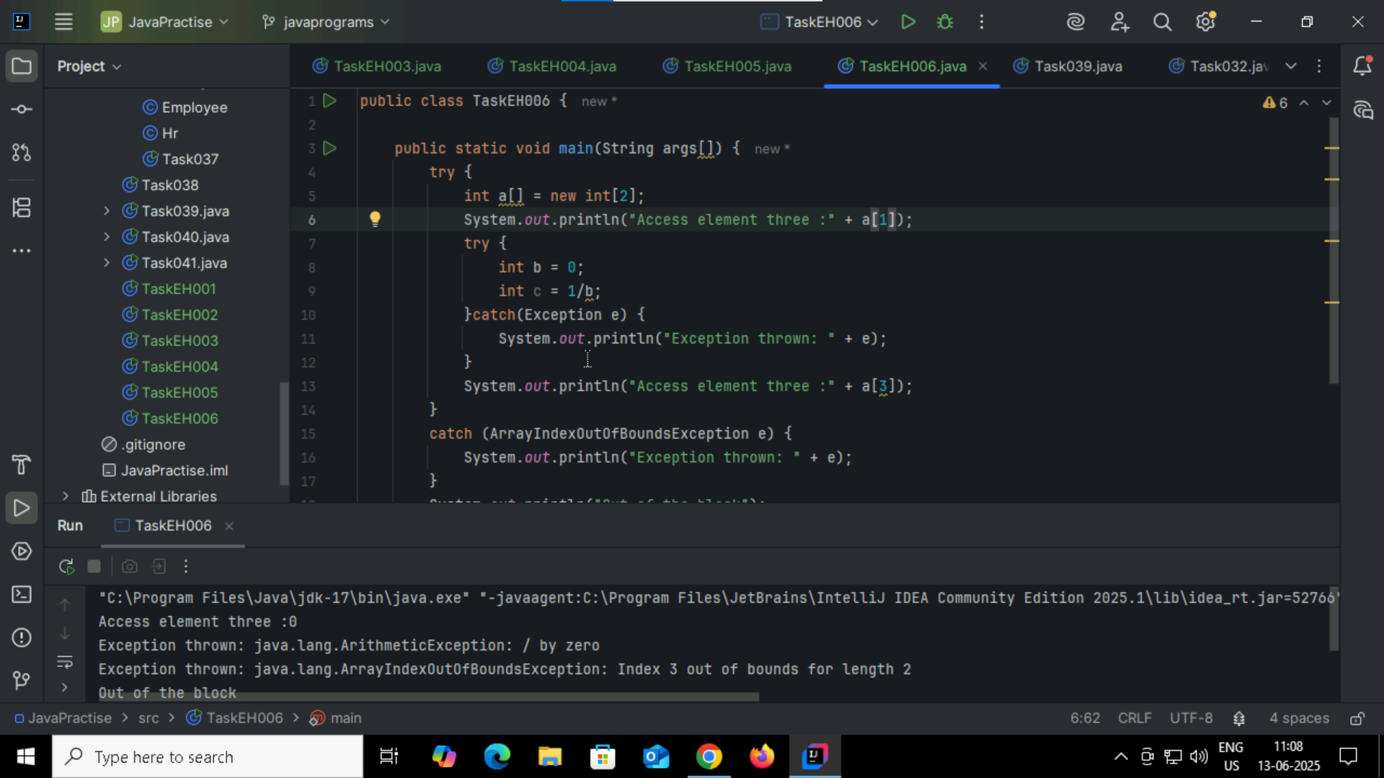Task007:

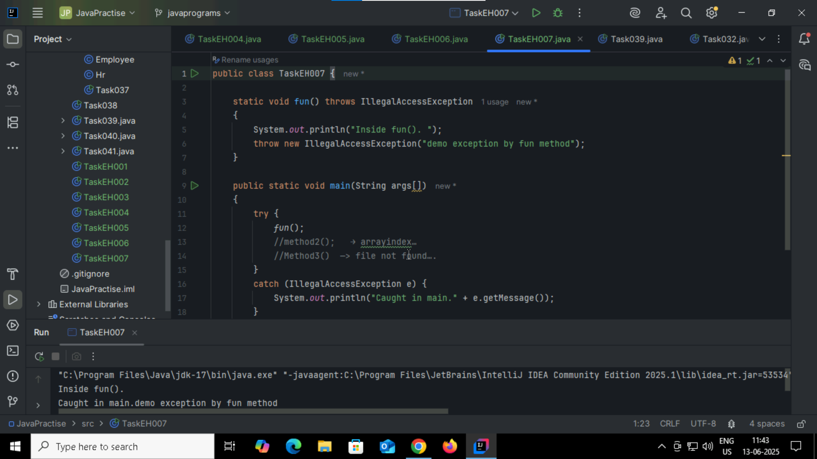

Task008:

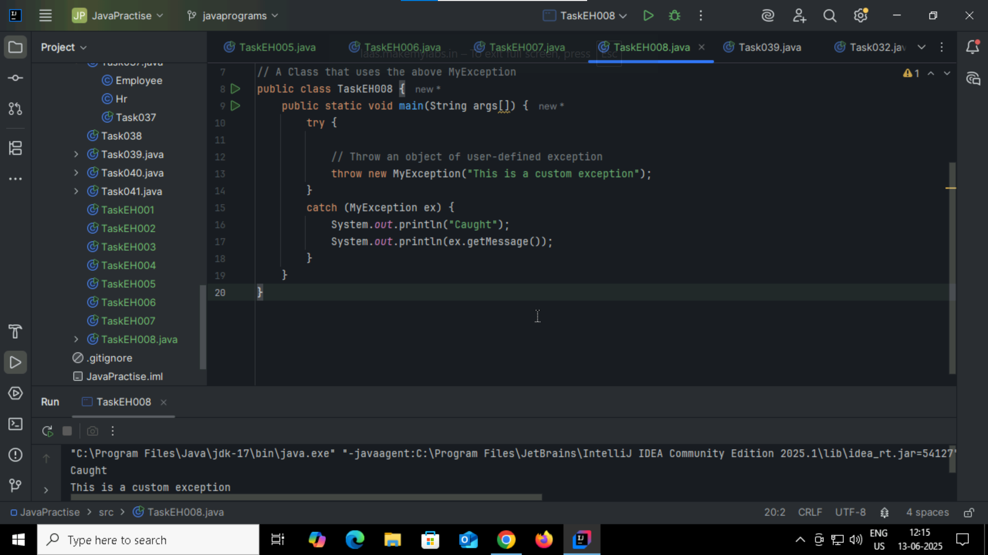

Task009: ArrayList  
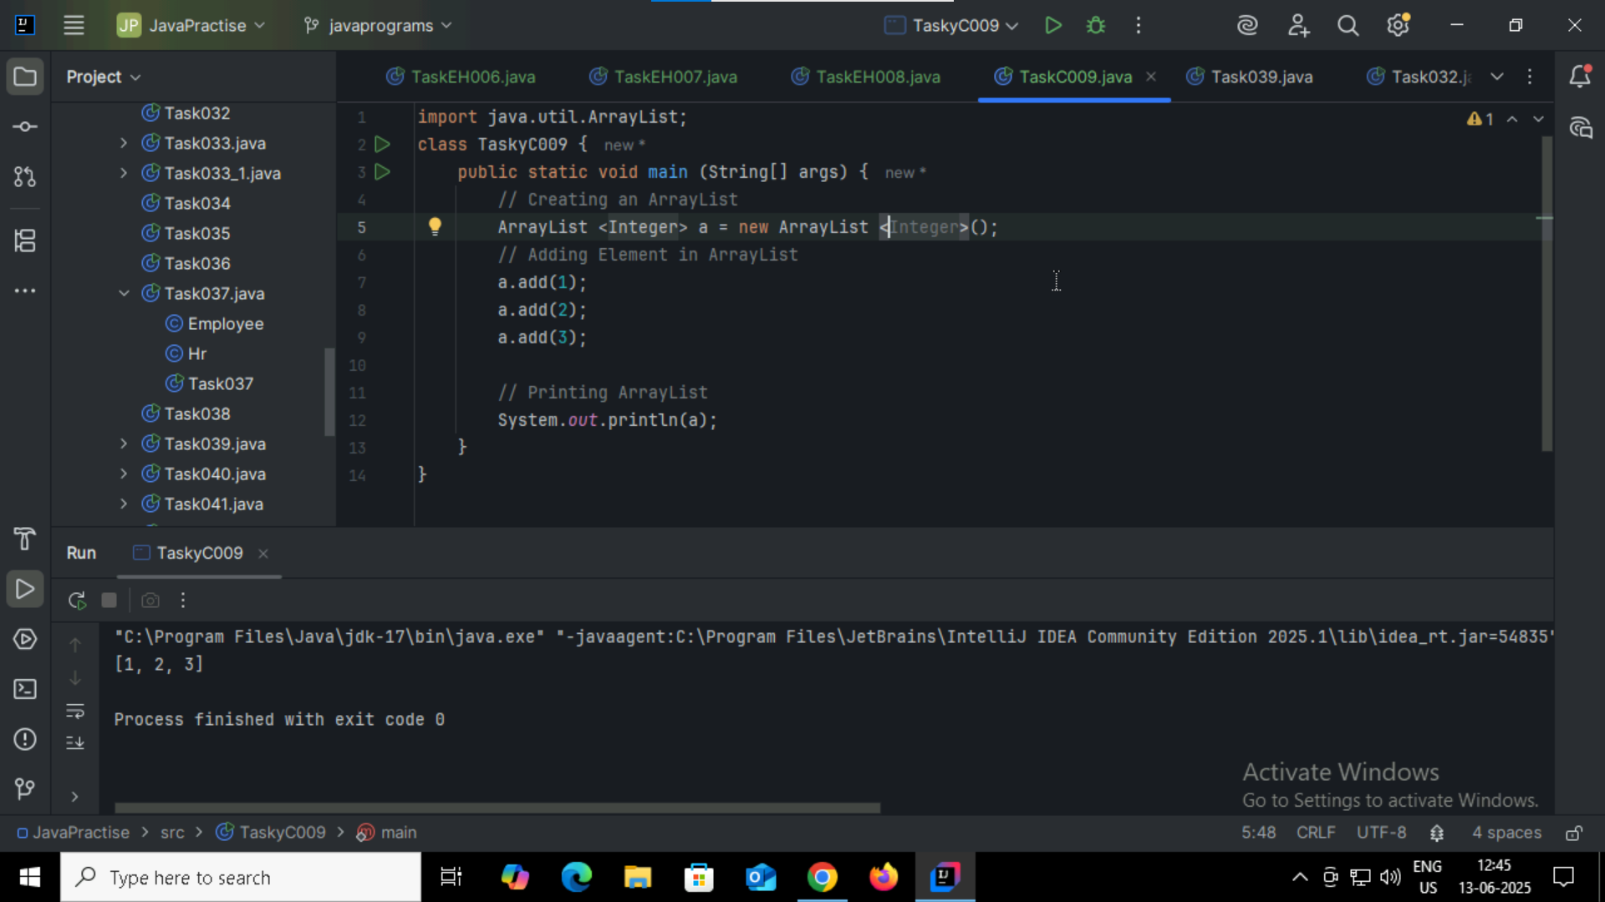

Task009_1  
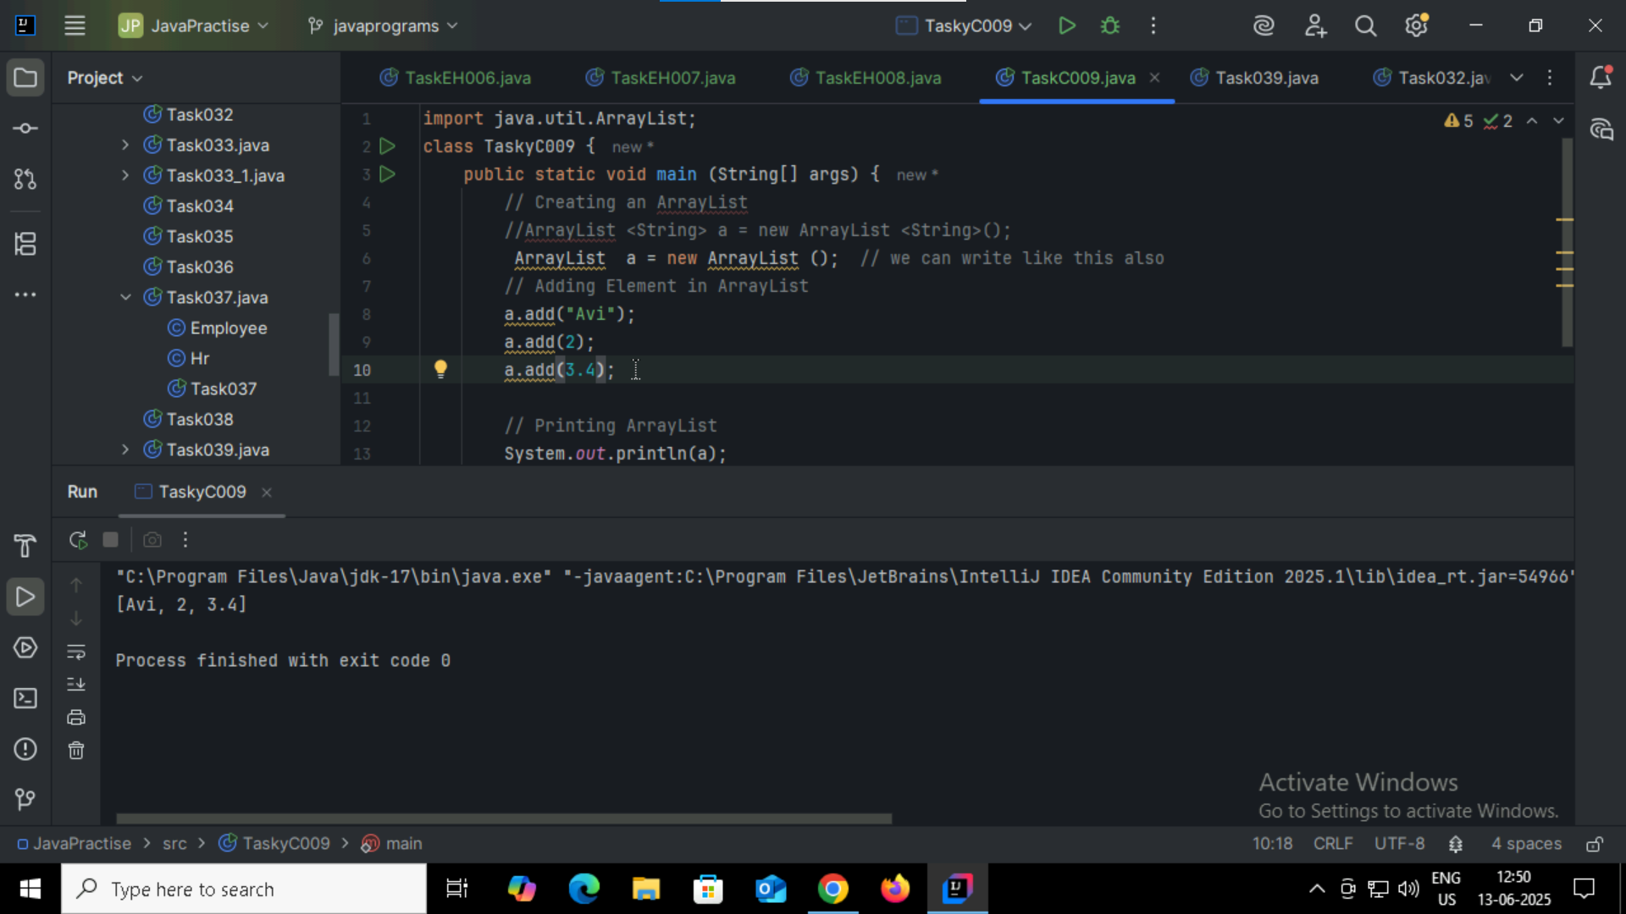

Task 10:

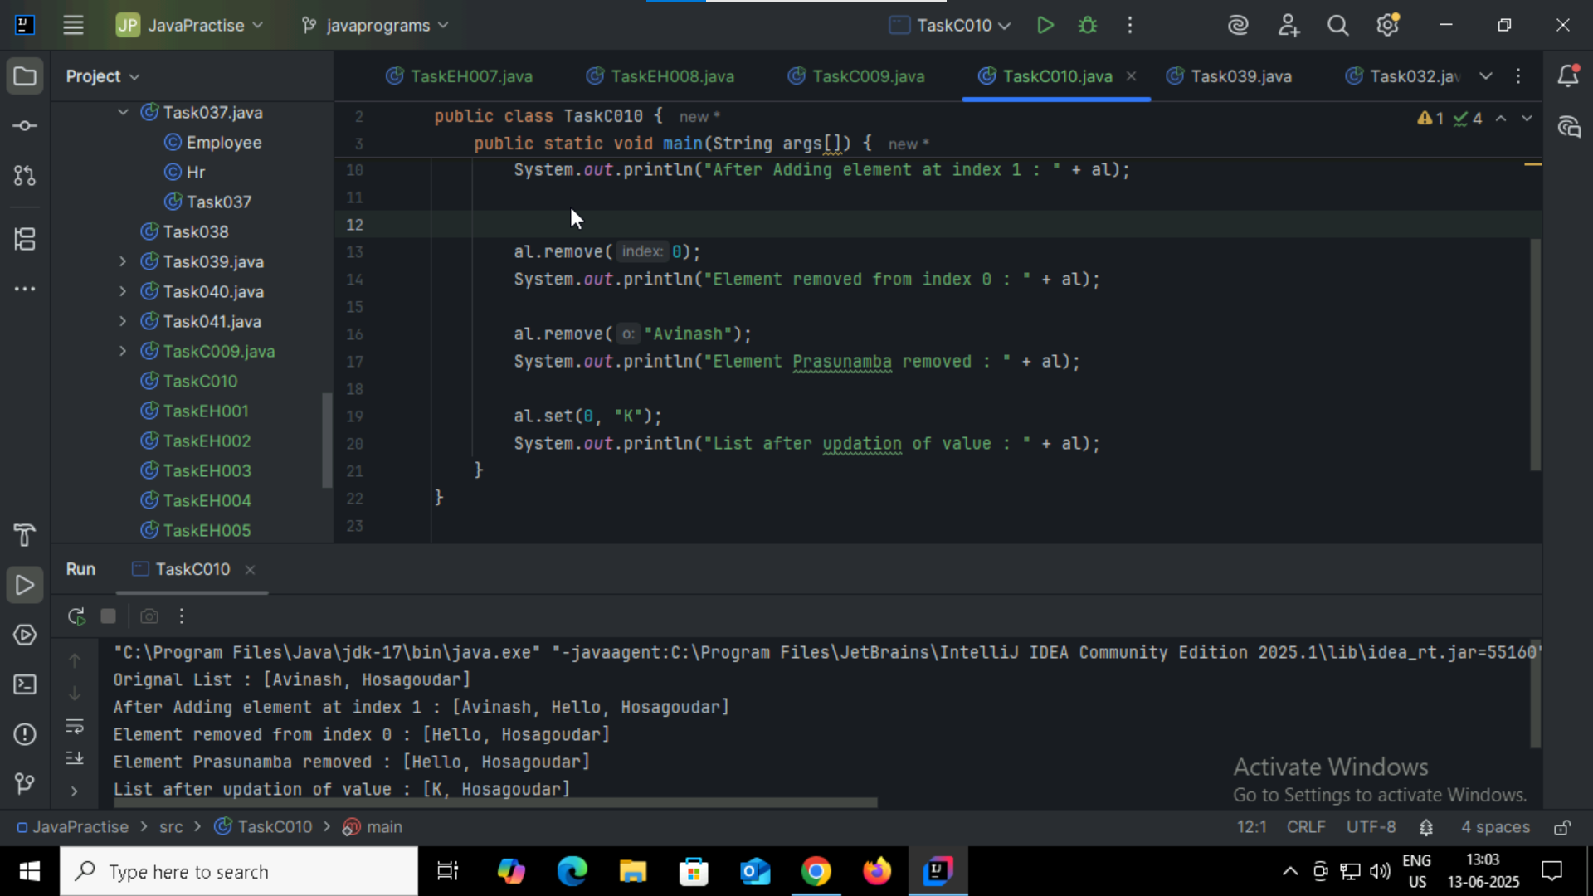

Object[] obj={1,'e',"hemant"};

for(Object o:obj){ System.out.println(o);} # using object we can store diff type of data in Array

Cloning :

ArrayList a1 = new ArrayList ();

a1.add(1);

a1.add(2);

a1.add(3);

ArrayList al2 = (ArrayList) al.clone();

System.out.println(al2);

Task011:

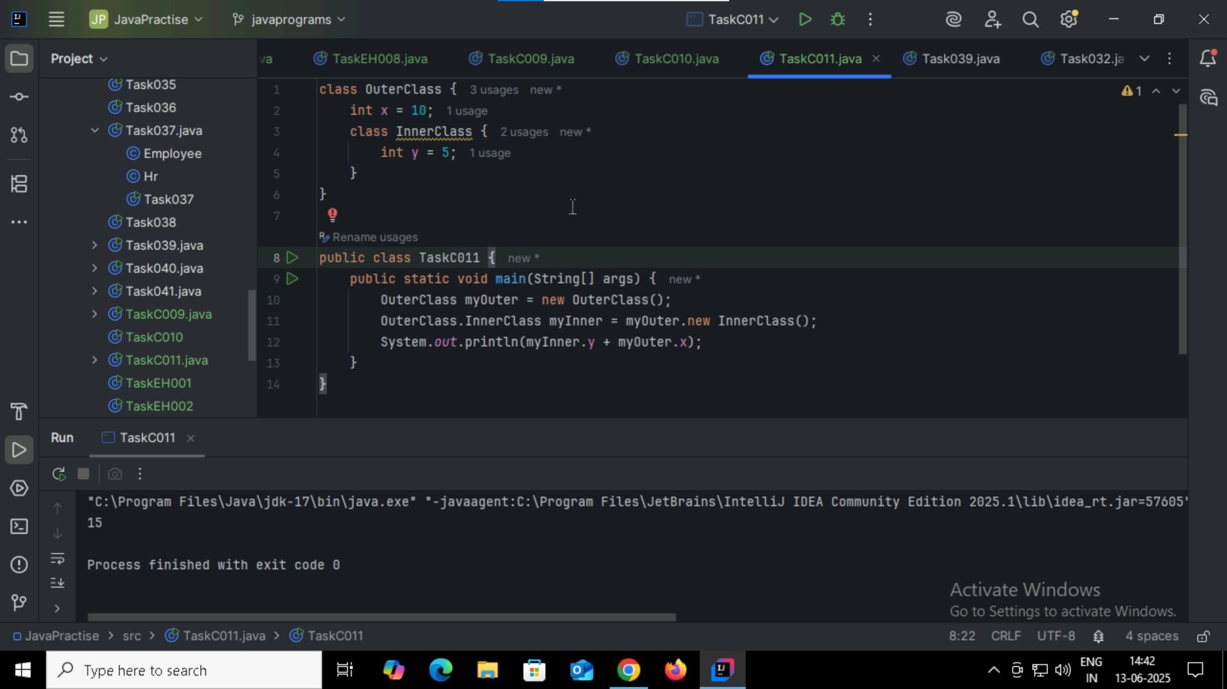

Task12: keeping InnerClass into private # we cannot access the value if we use private

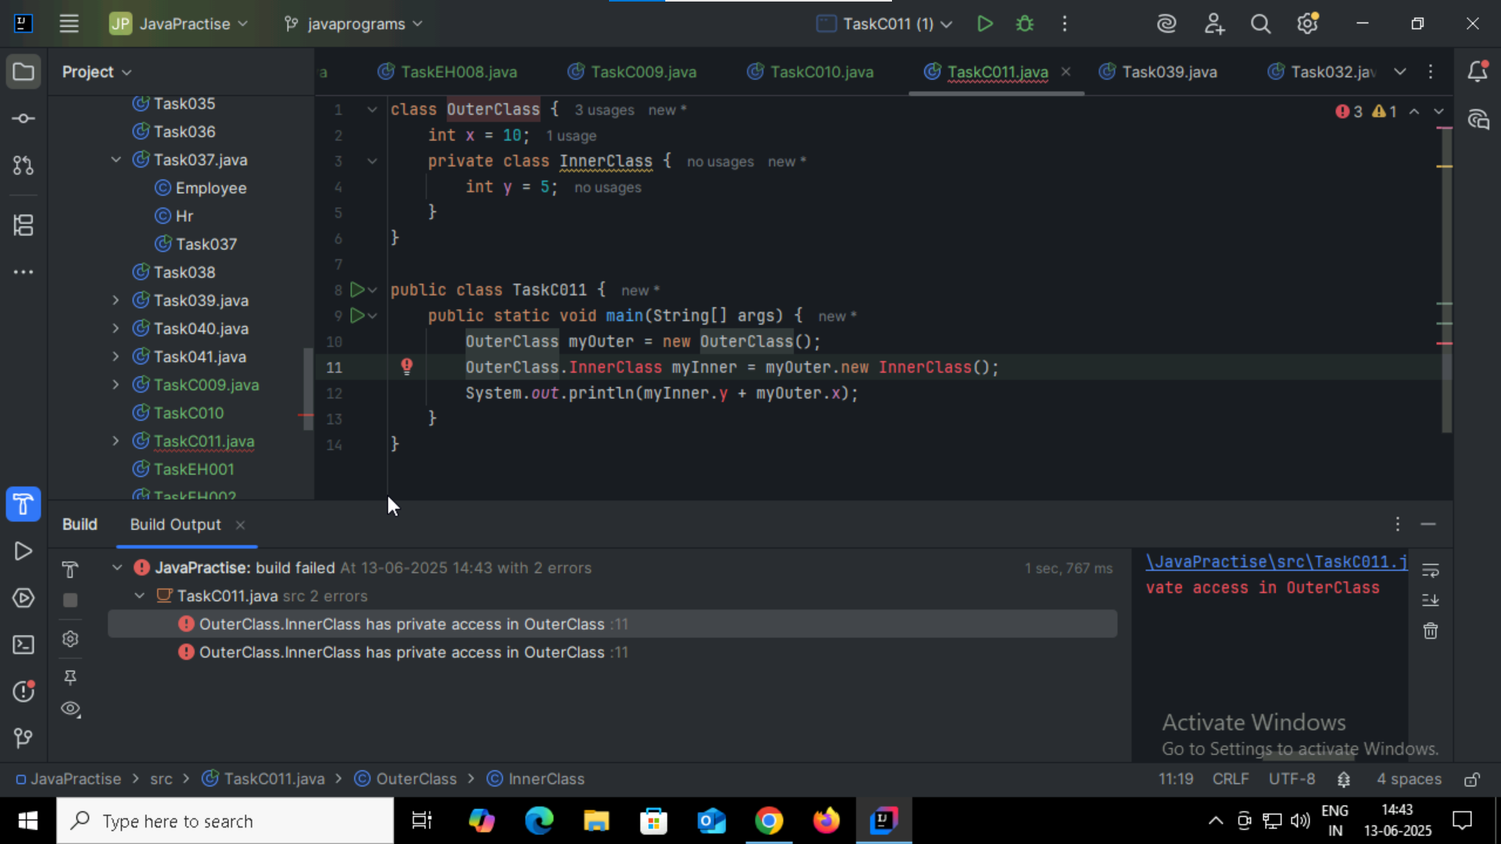

Task013: using static class

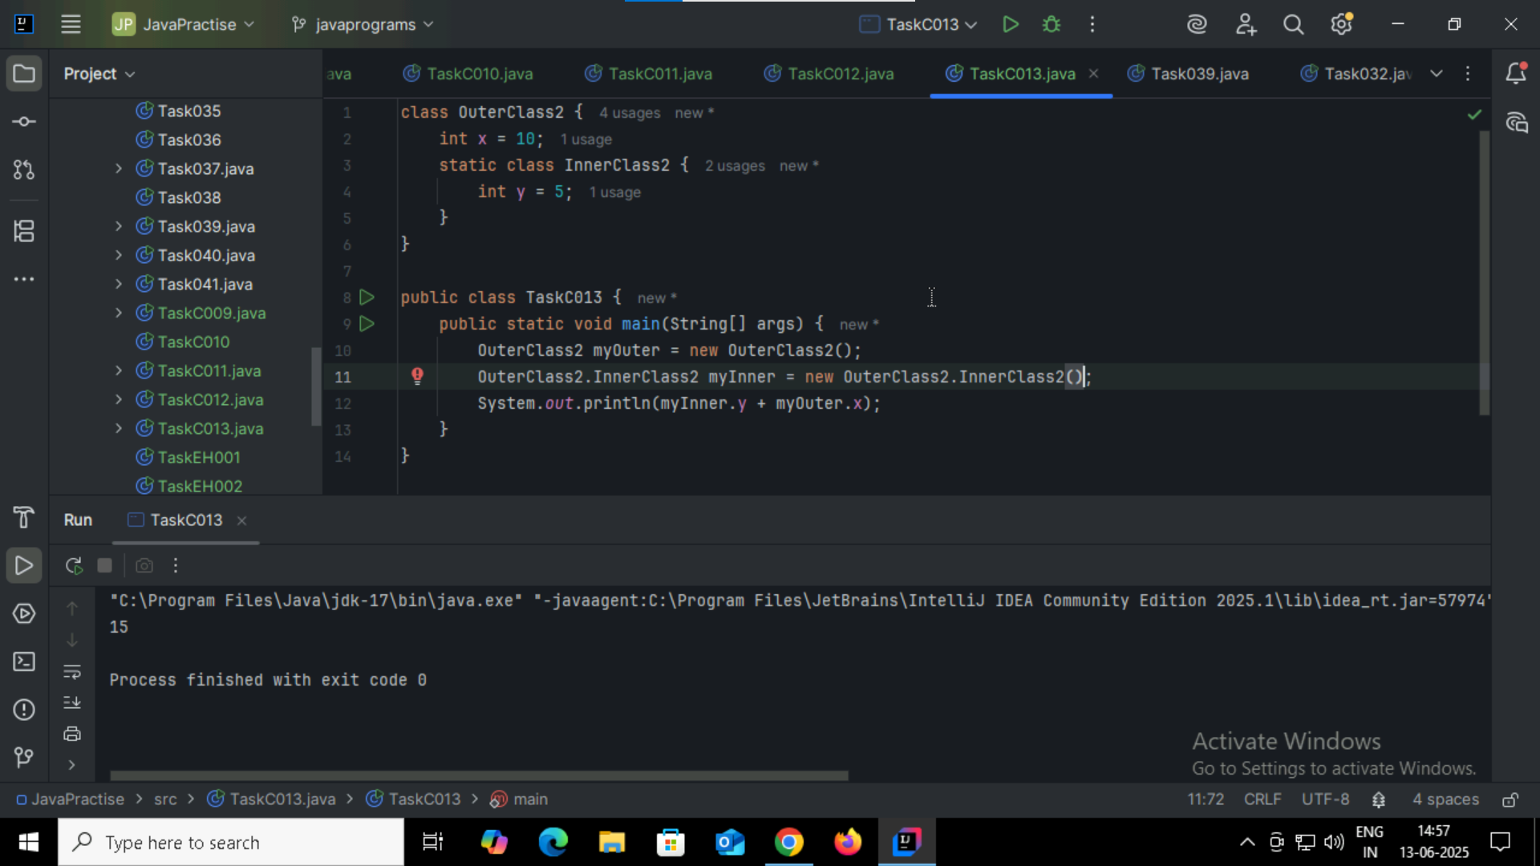

Task014:

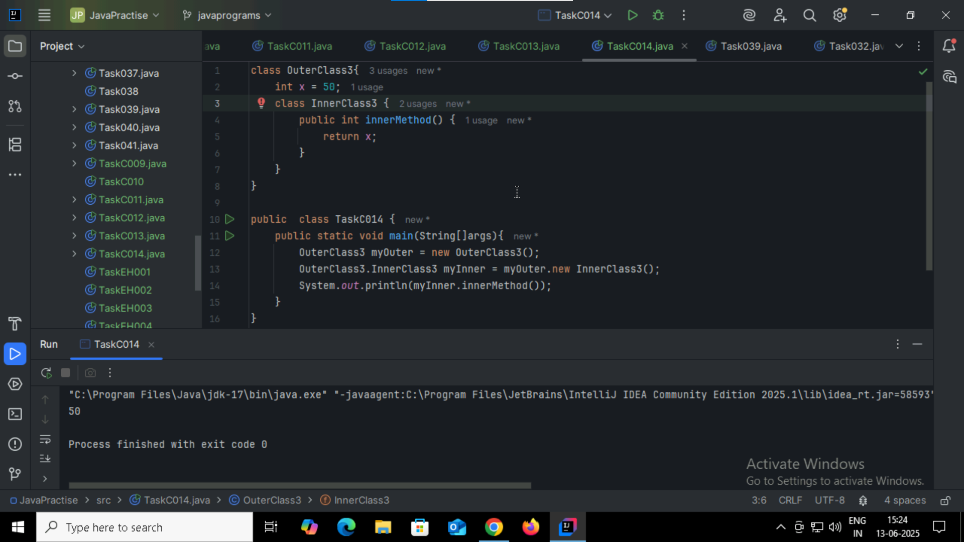

Task015: y is static, so it **belongs to the class**, not the object. That’s why it will show warning So using outerclass.innerclass.variablename this is proper way to access the value

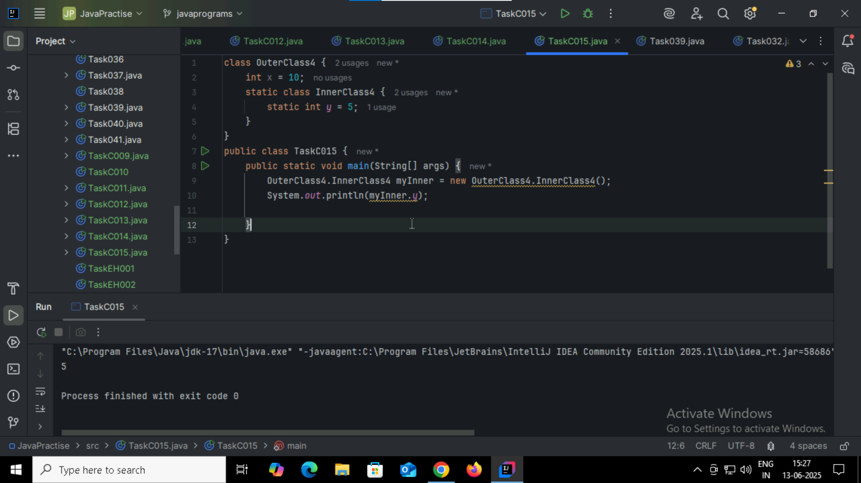

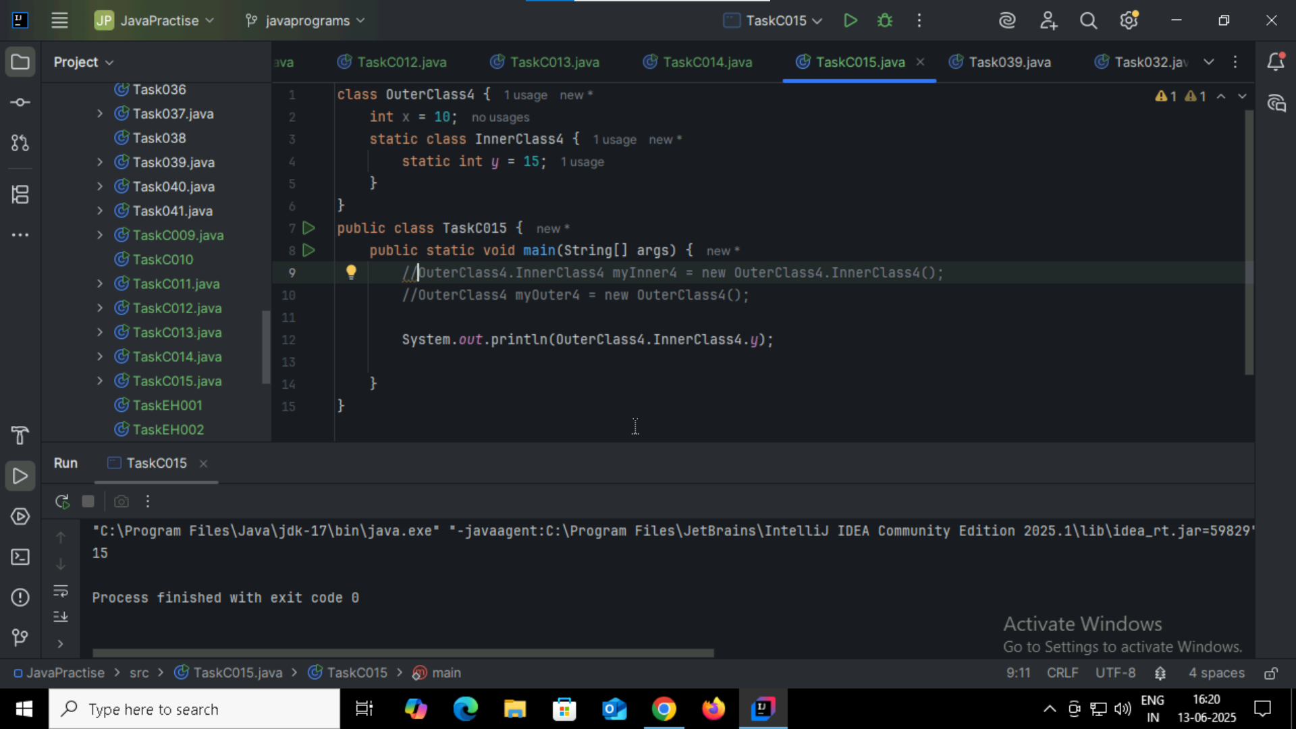

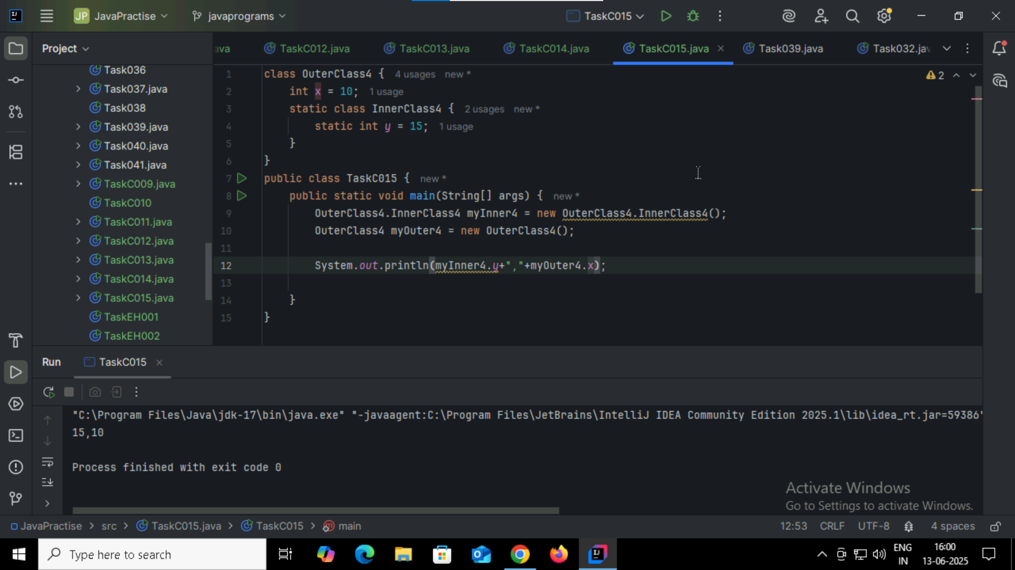

Task 16: HW

Task017:

Features of java:

* Lambda Expression: **Syntax**: (arguments) -> { body }
* Functional Interface:
* Stream API
* Default & Static Methods in Interface
* Method References
* Optional Class
* Collector API
* For each () method

Task18:

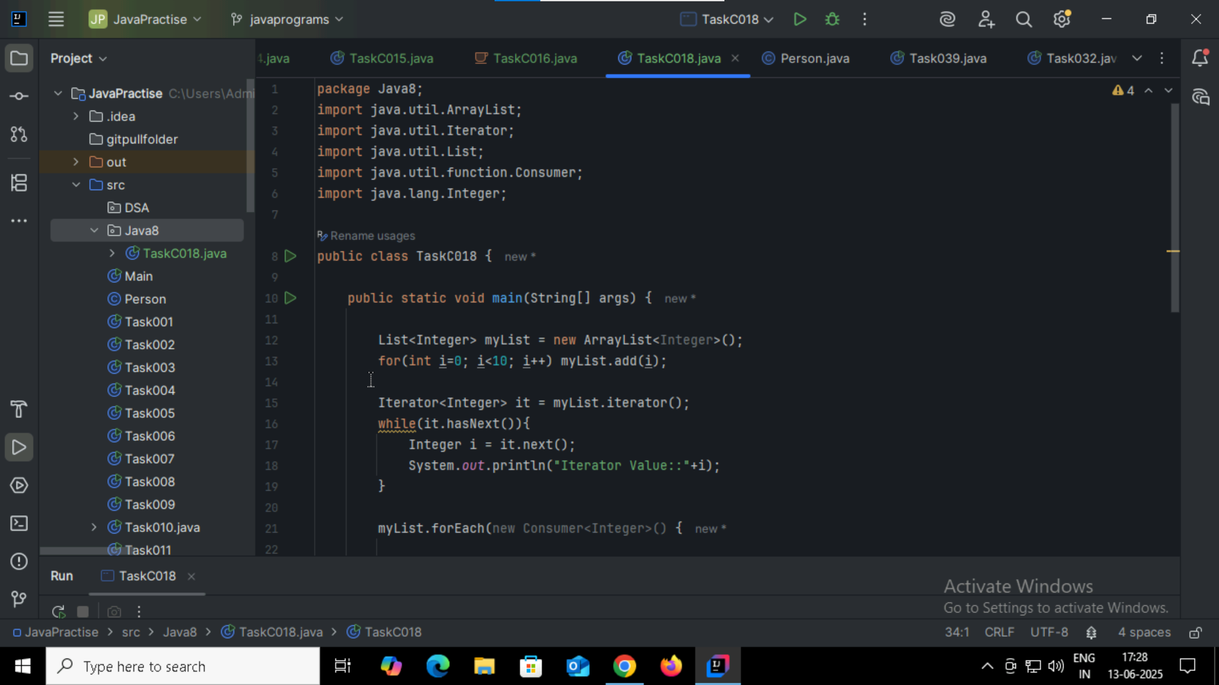

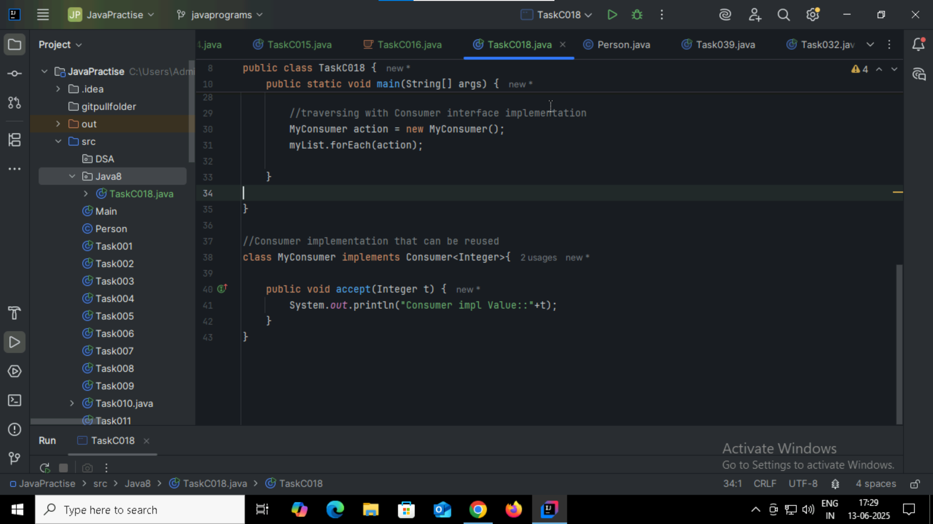

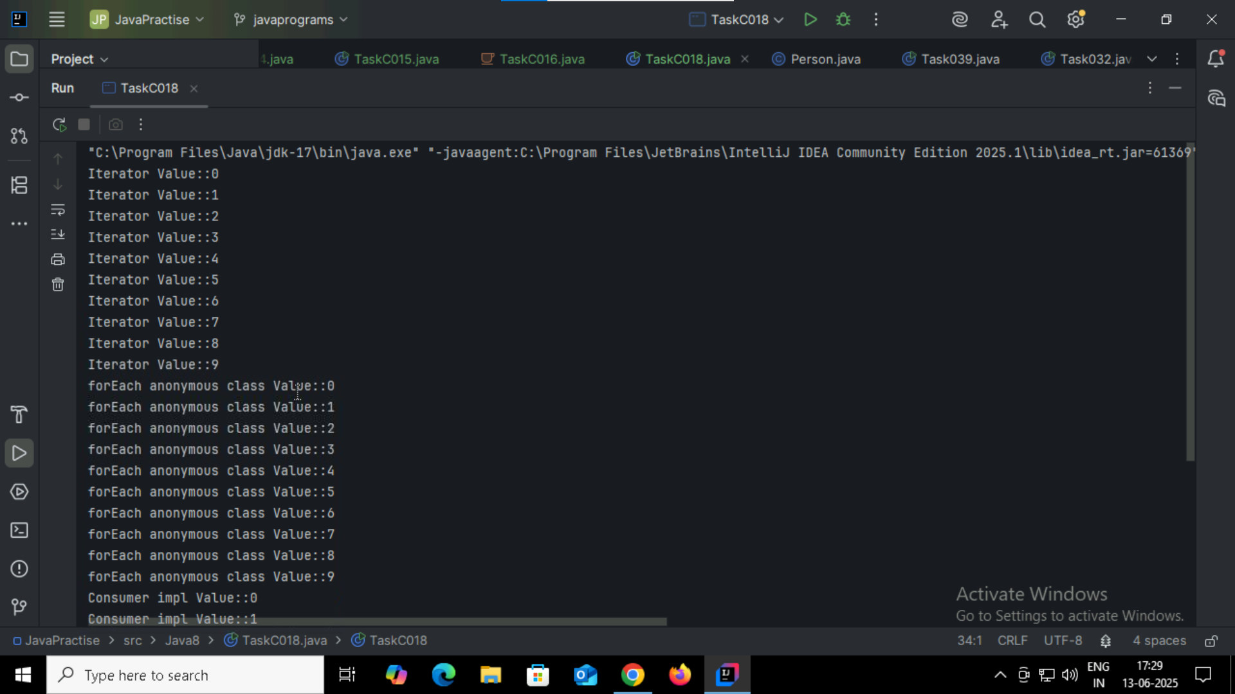

Task 19: Java 8 features

<https://www.digitalocean.com/community/tutorials/java-8-features-with-examples>

Task20:

